**Wedding Celebration Project**

Soohwan Kim

**Project Description**

This project proposal is for planning a wedding celebration on December 2 in Orlando, Florida, uniting a close family member with a US politician. The vision is to create a wedding that honors the intimacy of family bonds while reflecting the groom’s public stature. With a combined budget of CAD $100,000 from the bride's family and USD $100,000 from the groom's, the event will blend the joy of a traditional wedding with designated areas for the groom's fundraising efforts. This multifaceted celebration seeks to deliver an elegant and unforgettable experience, honoring both family traditions and the groom's political role.

**Project Scope Management**

# Requirements

* Must accommodate a large number of guests comfortably, with designated areas for both socializing and fundraising.
* Venue should offer convenient access, parking, and accessibility features for guests of all ages.
* Catering services that accommodate diverse dietary needs and preferences, including options for both formal dining and casual refreshment stations.
* Designated space for fundraising activities that are subtly integrated into the event flow.
* Professional staff available throughout the event for guest support, catering, and cleanup.
* Secure and temperature-controlled storage for perishables and sensitive items (e.g., flowers, certain food items).

# Scope statement

## Product scope description

The project involves planning, organizing, and hosting a distinguished wedding celebration in Orlando, Florida, scheduled for December 2. This event will merge a classic wedding ambiance with designated areas for the groom’s fundraising initiatives. Designed as an elegant and joyful occasion, it will bring together family, friends, and the groom’s associates in a secure and welcoming setting. Through careful coordination, the event will celebrate the couple’s union while supporting the groom’s professional aspirations and ensuring seamless logistical execution.

## Product acceptance criteria

The wedding aligns with the couple’s specifications and family expectations while staying within the allocated budget.

Health and safety standards, particularly for large gatherings, are fully observed throughout.

Guests provide favorable feedback on accessibility, event organization, and flow.

All facilities and services operate seamlessly, with well-coordinated catering, entertainment, and fundraising components.

## Project deliverables

A comprehensive plan detailing the wedding location, event schedule, guest accommodations, and staff assignments.

A well-organized team of event staff trained to handle both family and public event requirements, including security and safety.

An outreach and communication plan to keep guests informed, using social media, invitations, or press releases as needed.

## Project exclusions

The project does not cover transportation for guests to or from Orlando.

The project does not include responsibility for any post-wedding events.

Health monitoring of guests post-event is outside the project's scope.

This event only covers the wedding celebration, excluding pre-wedding events such as rehearsals or private family gatherings.

## Project constraints

The budget is capped at a combined CAD $100,000 and USD $100,000.

The venue must be spacious enough to comfortably host all guests, with dedicated areas for dining and fundraising.

Availability of skilled event staff is required to manage logistics and guest services effectively.

The event must adhere to all health and safety guidelines, including COVID-19 protocols as needed.

The setup and takedown of the venue are limited to the single-day schedule of the event.

## Project assumptions

The venue will provide adequate space and facilities for both wedding and fundraising activities.

All necessary items (such as seating, sound, and lighting equipment) will be accessible and in working condition on the day.

Weather will be favorable, ensuring smooth transportation, setup, and guest arrival.

Vendor supply chains will be consistent, with dependable access to food, decor, and essential supplies.

**Project WBS & Schedule**

## WBS

Wedding Project

Accommodation Arrangements

Seating Arrangements

Financial Recheck

Thank-You Notes

Event Evaluation

Music Setup

Lighting Setup

Program Scheduling

Area Setup

Donation Collection

Event Promotion

Waste Disposal

Food Service

Dietary Accommodations

Menu Selection

Transportation Coordination

Guest Check-in

Invitations and RSVP Tracking

Clean up

Decoration

Venue Booking

Venue & Logistics

Guest Management

Fundraising

Post Event

Entertainment

Dining

Stakeholder

Management

Plan

Project Description

Event

Documentation

Network

Diagram

WBS

Schedule

Risk

Management

Scope

Management

## Assumptions used to develop estimates

**Venue Setup**

* and teardown will require a minimum of 1 day each.

**Catering**

* includes setup, service, and teardown over a 10-hour event.

**Invitations**

* are sent 2-3 months prior, and RSVPs finalized 2 weeks before.

**Entertainment and AV Setup**

* requires skilled technicians for installation and sound checks.

**Guest Transportation**

* assumes coordination for around 200 guests from hotels to the venue.

**Fundraising Arrangements**

* assume pre-planned marketing and coordination with volunteers.

## Dependency Matrix

|  |  |  |  |  |  |
| --- | --- | --- | --- | --- | --- |
| Major  Deliverables | Supporting  Deliverables | Work  Package | Name | Duration | Dependency |
| Documentation |  |  |  |  |  |
|  |  | Project Description | A | 2 |  |
|  |  | Scope  Management | B | 2 | A |
|  |  | Risk  Management | C | 1 | A, B |
|  |  | Stakeholder  Management  Plan | D | 3 | A, B |
|  |  | Schedule | E | 2 | B |
|  |  | WBS | F | 2 | A, B, C |
|  |  | Network  Diagram | G | 1 | A, B, C |
| Project:  Wedding Event |  |  |  |  |  |
|  | Venue & Logistics |  |  |  |  |
|  |  | Venue Booking | H | 1 | B,I,L |
|  |  | Decoration | I | 3 | H |
|  |  | Clean up | J | 1 | H |
|  |  | Seating Arrangements | K | 1 | H,S |
|  | Dining |  |  |  |  |
|  |  | Menu Selection | L | 2 | H,B |
|  |  | Dietary Accommodations | M | 2 | H,B |
|  |  | Food Service | N | 3 | H,C |
|  |  | Waste Disposal | O | 1 | H |
|  | Entertainment |  |  |  |  |
|  |  | Program Scheduling | P | 5 | A, B,C |
|  |  | Lighting Setup | Q | 1 | H |
|  |  | Music Setup | R | 2 | H,L |
|  | Guest Management |  |  |  |  |
|  |  | Invitations and RSVP Tracking | S | 1 | H,B |
|  |  | Accommodation Arrangements | T | 2 | H |
|  |  | Transportation Coordination | U | 3 | H |
|  |  | Guest Check-in | V | 2 | A |
|  | Fundraising |  |  |  |  |
|  |  | Event Promotion | W | 3 | H |
|  |  | Donation Collection | X | 2 | B,H,I |
|  |  | Area Setup | Y | 3 | H |
|  | Post Event |  |  |  |  |
|  |  | Event Evaluation | Z | 1 | A,B,C,H,J |
|  |  | Thank-You Notes | AA | 2 | A |
|  |  | Financial Recheck | BB | 2 | A,C,D |

## Network Diagram

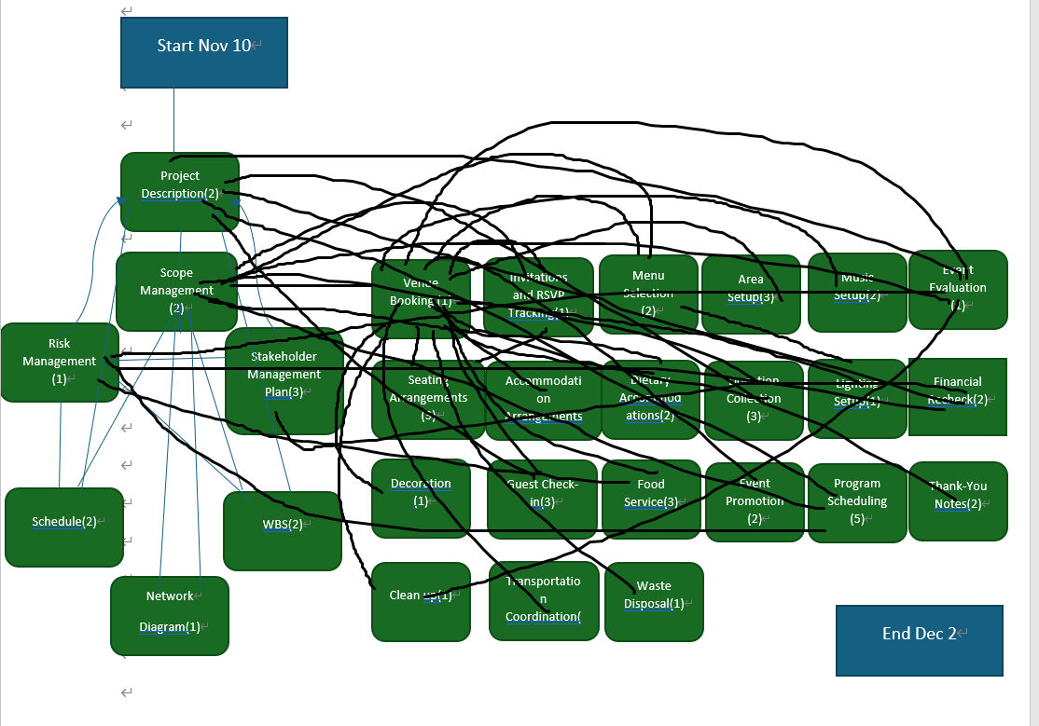

## Qualitative Statement about the Schedule

The critical path focuses on tasks where timing is tight and dependencies are high, especially around venue setup, guest RSVPs, and event coordination. The greatest risks to timeline delays lie in RSVP tracking and coordination of vendors (catering, AV setup) that must align precisely to ensure timely setup for the event.

## Project Budget Summary

|  |  |
| --- | --- |
| **Activity** | **Estimated Cost (CAD/USD)** |
| Venue & Logistics (Booking, Setup, Teardown) | CAD $15,000 / USD $10,000 |
| Catering (Menu Selection, Service, Dietary Accommodations) | CAD $20,000 / USD $15,000 |
| Entertainment (Program Scheduling, AV Setup) | CAD $12,000 / USD $10,000 |
| Guest Management (Invitations, Accommodations, Transportation) | CAD $10,000 / USD $8,000 |
| Fundraising (Event Promotion, Donation Collection) | CAD $8,000 / USD $7,000 |
| Post Event (Event Evaluation, Thank-You Notes, Financial Recheck) | CAD $5,000 / USD $4,000 |
| Miscellaneous & Contingency | CAD $10,000 / USD $8,000 |
| **Total Budget** | **CAD $100,000 / USD $100,000** |

**Risk Management**

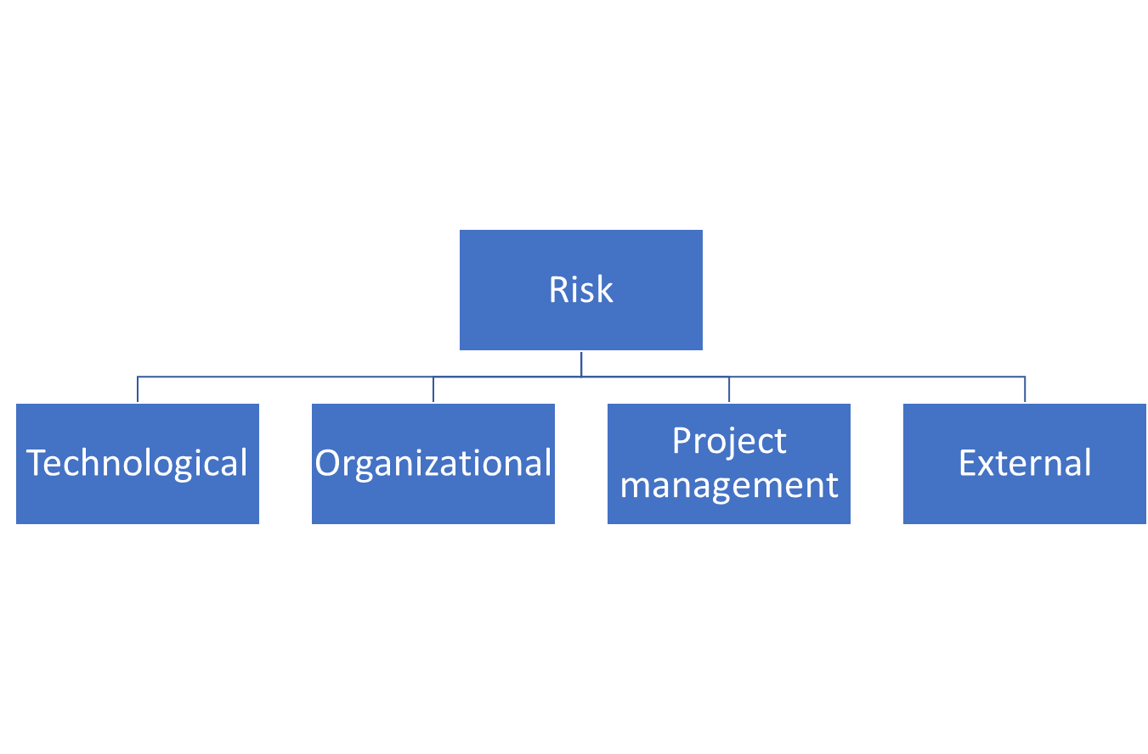

**Technological Risks:**

Event Management Software Failure

AV System Malfunction

Online RSVP System Failure

Power Outage

Wi-Fi or Internet Connectivity Issues

**Organizational Risks:**

Understaffing

Security Risks

Miscommunication Among Teams

Lack of Adequate Seating

Inadequate Guest Accommodations

**Project Management Risks:**

Scope Creep

Delays in Vendor Deliveries

Budget Overruns

Poor Risk Management

Coordination Failures

**External Risks:**

Bad Weather

Traffic or Transportation Delays

Health and Safety Concerns

Political Disruptions

1. Complete the following table (add as many rows as necessary):

|  |  |  |  |  |  |
| --- | --- | --- | --- | --- | --- |
| **Risk Event** | **When** | **Likelihood**  **(Scale 1-5)** | **Impact**  **(Scale 1-5)** | **Ease of detection** | **Risk value** |
| Event Management Software Failure | Before event | 3 | 4 | 3 | 36 |
| AV System Malfunction | During event | 2 | 5 | 3 | 30 |
| Online RSVP System Failure | Before event | 3 | 4 | 4 | 36 |
| Power Outage | During event | 2 | 5 | 2 | 20 |
| Wi-Fi or Internet Connectivity Issues | During event | 3 | 3 | 4 | 36 |
| Understaffing | During event | 4 | 4 | 3 | 48 |
| Security Risks | During event | 3 | 5 | 2 | 30 |
| Miscommunication Among Teams | Throughout event planning | 3 | 4 | 3 | 36 |
| Lack of Adequate Seating | During event | 3 | 3 | 4 | 36 |
| Inadequate Guest Accommodations | Before event | 2 | 4 | 3 | 24 |
| Scope Creep | Throughout event planning | 3 | 4 | 4 | 48 |
| Delays in Vendor Deliveries | Before or during event | 3 | 4 | 3 | 36 |
| Budget Overruns | Throughout event planning | 2 | 5 | 3 | 30 |
| Poor Risk Management | Throughout event planning | 2 | 4 | 4 | 32 |
| Coordination Failures | During event | 3 | 4 | 3 | 36 |
| Bad Weather | Day of event | 2 | 5 | 2 | 20 |
| Traffic or Transportation Delays | Day of event | 3 | 3 | 4 | 36 |
| Health and Safety Concerns | During event | 2 | 5 | 3 | 30 | 1 | 5 |
| Political Disruptions | During event | 1 | 5 | 2 | 10 | 4 | 24 |

1. Complete the following graph

Likelihood

|  |  |  |  |  |  |
| --- | --- | --- | --- | --- | --- |
| 5 |  |  | Record Keeping |  |  |
| 4 |  | Scope Creep, , |  | Security Risks, Understaffing |  |
| 3 | Political Disruptions | Limited Seating, | Wi-Fi or Internet Connectivity Issues, Lack of Adequate Seating, Transportation Delays | Coordination Failures, Delays in Vendor Deliveries, Scope Creep, Miscommunication Among Teams, RSVP System Failure, Event Management Software Failure |  |
| 2 |  |  |  | Unforeseen Legal Issues, Poor Risk Management, Inadequate Guest Accommodations | Bad Weather ,Health and Safety Concerns, Budget Overruns, Power Outage, AV System Malfunction |
| 1 |  |  |  |  | Political Disruptions |
|  | 1 | 2 | 3 | 4 | 5 |

Impact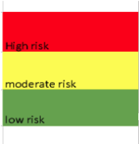

1. For each risk, recommend a response by completing the following table:

|  |  |  |
| --- | --- | --- |
| **Event** | **Response** | **Contingency** |
| Event Management Software Failure | Implement backups and manual tracking | Use a paper backup system and ensure a team is ready to take over manually |
| AV System Malfunction | Test AV systems prior to event and ensure technical support is on-site | Have a backup AV system or technician on standby |
| Online RSVP System Failure | Confirm all RSVPs through email or phone | Manually track RSVPs and ensure an alternative communication method is available |
| Power Outage | Check all electrical systems before the event and have backup generators available | Ensure backup generators are in place and working |
| Wi-Fi or Internet Connectivity Issues | Ensure a dedicated and reliable internet connection is provided for the event | Set up a backup connection or ensure offline activities are planned |
| Understaffing | Hire additional temporary staff for the event day | Have a flexible staff roster with clear task delegation |
| Security Risks | Hire professional security personnel and conduct a thorough risk assessment | Have additional security personnel on standby, with clear protocols in place |
| Miscommunication Among Teams | Establish clear communication channels and regular check-ins with all teams | Have a communication coordinator or a backup contact person ready |
| Lack of Adequate Seating | Confirm seating arrangements in advance and account for all guests | Rent extra chairs and have a flexible seating plan available |
| Inadequate Guest Accommodations | Confirm all accommodations with the venue and guests well in advance | Have a list of nearby hotels and ensure transport arrangements are in place |
| Scope Creep | Clearly define the event scope and maintain strict budget controls | Prioritize key event elements and limit changes during planning |
| Delays in Vendor Deliveries | Confirm timelines and create a detailed contract with each vendor | Have backup vendors or extra supplies on hand |
| Budget Overruns | Monitor spending carefully and stick to the budget | Allocate contingency funds for unforeseen expenses |
| Poor Risk Management | Regularly update and review risk management plans | Have a designated risk manager and update the plan throughout the event process |
| Coordination Failures | Maintain clear roles and responsibilities, and ensure continuous communication | Have backup coordinators and reassign tasks as needed |
| Bad Weather | Monitor weather forecasts and prepare indoor or sheltered event options | Secure an indoor venue or tents in case of inclement weather |
| Traffic or Transportation Delays | Confirm transportation arrangements well in advance | Have alternative transport options ready or ensure timely arrival |
| Health and Safety Concerns | Follow local health and safety regulations and provide necessary precautions | Ensure on-site medical personnel and first aid kits are available |
| Political Disruptions | Monitor any political situations that may affect the event | Secure a private area for sensitive guests and monitor political developments |

**Stakeholder Management**

**Who are they?**

Bride's family, Groom's family, Wedding planners, Event staff (caterers, security, coordinators), Guests (family, friends, associates), Vendors (catering, decor, AV, entertainment)

**What are their interests?**

Bride’s family: Ensuring the event aligns with family traditions, comfort for guests, staying within budget.

Groom’s family: Wanting a high-profile event that reflects the groom’s political status, ensuring fundraising goals are met.

Wedding planners: Ensuring a smooth event execution, meeting deadlines and quality standards.

Event staff: Successful event execution and clear roles, proper payment for services rendered.

Guests: Enjoying the event, good catering, and a smooth experience.

Vendors: Successful contracts, timely payments, and effective service delivery.

**Will their interest level vary throughout the project?**

Bride’s family: Yes, more involved in the early stages (planning) and less during the event.

Groom’s family: Yes, their interest will increase closer to the wedding date, particularly around fundraising and event publicity.

Wedding planners: Yes, more active in the planning phase, but stay engaged for execution.

Event staff: Yes, mostly involved during the event itself with preparation leading up to it.

Guests: Yes, interest peaks closer to the event, especially after receiving invitations.

Vendors: Yes, involved mostly in the logistical phases of the event (before and during).

**Can coalitions be built?**

Bride’s and groom’s families can form a coalition around budget and event goals, aligning on the final vision.

Wedding planners and event staff will work closely together to ensure a smooth event, aligning on logistics.

Vendors (catering, decor, etc.) will likely form coalitions with the planners to meet event requirements.

**The power/interest grid**

    ↑

Power

    ↓

|  |  |
| --- | --- |
| **Keep Satisfied**  Vendors | **Manage Closely**  Wedding planners |
| **Monitor ( Minimum Effort )**  Guests | **Keep Informed**  Event staff, Bride's family, Groom's family |

**←** Interest **→**

**Note: Interest and Power graded 1-2**

**Stakeholder analysis**

|  |  |  |  |  |
| --- | --- | --- | --- | --- |
| **Stakeholder Names and Roles** | **How important? (interest*power)** | **Current level (Unaware, Resistant, Neutral, Supportive, Leading)** | **Desired level** | **What actions are needed, by whom?** |
| Bride's Family (Primary Host) | 2 | Supportive | Leading | Engage early in planning, ensure their preferences are considered, maintain regular updates. Wedding planners and coordinators should communicate often with them. |
| Groom's Family (Primary Host) | 2 | Supportive | Leading | Provide input on key decisions related to the groom's public image and fundraising. Wedding planners should ensure their involvement in important decisions. |
| Wedding Planners | 4 | Leading | Leading | Keep the event on track, ensure smooth execution, and solve problems proactively. Regular communication and leadership by the planners are essential. |
| Event Staff (Caterers, Security, etc.) | 2 | Neutral | Supportive | Establish clear roles and responsibilities for the event. Wedding planners should manage schedules and ensure staff are well-prepared. |
| Guests (Family, Friends, Associates) | 1 | Neutral | Supportive | Provide clear communication about event details and expectations. Wedding planners should ensure the guests feel welcomed and informed. |
| Vendors (Catering, AV, Decor, etc.) | 2 | Neutral | Supportive | Ensure all agreements are clear and executed on time. Wedding planners should oversee the coordination between all vendors to ensure their services align with expectations. |

**Project Communication plan**

|  |  |  |  |
| --- | --- | --- | --- |
| **Communication deliverable** | **Audience** | **Form** | **Who** |
| Invitation | Guests (family, friends, associates) | Printed/Email Invitation | Wedding planners and bride’s/groom’s families |
| RSVP Confirmation | Guests | Email/Online RSVP | Wedding planners |
| Wedding Schedule and Itinerary | Guests, Wedding party | Printed/Online Document | Wedding planners |
| Vendor Contracts and Agreements | Vendors (catering, decor, AV, etc.) | Email, Written Contracts | Wedding planners, bride and groom |
| Team Meetings | Wedding planning team, vendors | In-person/Video Conference | Wedding planners and key team members |
| Thank You Notes/Follow-up Post Event | Guests, Vendors, Key stakeholders | Printed/Email | Bride and groom |

**Acceptance & Approval**

|  |  |  |
| --- | --- | --- |
| Name | Signature | Date |
| Soohwan Kim |  | 24/11/10 |
| Bride's Family Representative |  | 24/11/05 |
| Groom's Family Representative |  | 24/11/05 |

Reference –

<https://asana.com/resources/work-breakdown-structure>

When developing the proposal, consider the following questions and answer them in an appendix. Please provide a short explanation for each question (1 mark each).

1. To whom do you report?

- I report to both the bride’s and groom’s families, along with any relevant stakeholders or sponsors involved in the wedding, such as political associates or fundraising partners. Since this is a collaborative project, clear and open communication with all parties is necessary.

2. Will you be accountable for how much money will be raised?

- Yes, if the wedding includes a fundraising component, I may be responsible for monitoring how much money is raised. As part of the overall event management, I will need to ensure that the funds raised meet the set expectations.

3. What should be in place for this project to be successful?

- For this project to succeed, clear communication and careful planning are essential. Most importantly, it is critical to ensure that both the bride and groom are satisfied with the outcome, given the personal nature of the event.

4. Your family member did not require ice cream for guests. A few weeks into the project, she asks you to include it in the scope. Should you accept this?

- This request should be assessed based on the project's scope, timeline, and budget. While I may need to accommodate the request since it’s their wedding, I will need to make adjustments to ensure it fits within the plan. It’s important to manage changes carefully to avoid straying too far from the original objectives.

5. A few weeks into the project, your family member changes her mind about the music band for the party. You have already contracted a band to play the music. What do you do?

- I would try to find a way to change the band, if possible, within the budget and timeline. However, I must also consider any cancellation fees or penalties associated with altering the contract and weigh whether it is worth making the change.

6. Your family member did not require ice cream for guests. You find some budget and use it to order ice cream for guests. This is an example of:

This situation is an example of "scope creep," where a small change is made to the original plan. Since the adjustment is within the available budget, it can be handled without significant disruptions to the overall project.

7. Should your family member require regular progress reports?

Yes, regular progress reports are necessary to keep the family informed about the event’s status, budget, timeline, and any potential risks or issues that could arise. Regular updates will help ensure that everyone stays aligned and that any challenges can be addressed quickly.